Justin Clarke 121810311056

Web technologies Assignment

Question One

<!DOCTYPE html>
<html>
<head>
<meta charset="utf-8">
<title>timetable</title>

<!-- css-stylesheets -->
<link rel="stylesheet" href="https://stackpath.bootstrapcdn.com/bootstrap/4.5.1/css/bootstrap.min.css" integrity="sha384-VCmXjywReHh4PwowAiWNagnWcLhlEJLA5buUprzK8rxFgeH0kww/aWY76TfkUoSX" crossorigin="anonymous">

<!-- bootstrap -->
<script src="https://code.jquery.com/jquery-3.5.1.slim.min.js" integrity="sha384-DfXdz2htPH0lsSSs5nCTpuj/zy4C+OGpamoFVy38MVBnE+IbbVYUew+OrCXaRkfj" crossorigin="anonymous"></script>
<script src="https://cdn.jsdelivr.net/npm/popper.js@1.16.1/dist/umd/popper.min.js" integrity="sha384-9/reFTGAW83EW2RDu2S0VKaIzap3H66lZH81PoYlFhbGU+6BZp6G7niu735Sk7lN" crossorigin="anonymous"></script>
<script src="https://stackpath.bootstrapcdn.com/bootstrap/4.5.1/js/bootstrap.min.js" integrity="sha384-XEerZL0cuoUbHE4nZReLT7nx9gQrQreJekYhJD9WNWhH8nEW+0c5qq7aIo2Wl30J" crossorigin="anonymous"></script>
</head>
<body>
<table class="table table-hover">
<thead>
<tr>
<th scope="col">Time</th>
<th scope="col">9 AM</th>
<th scope="col">10 AM</th>
<th scope="col">11 AM</th>
<th scope="col">12 AM</th>
<th scope="col">1 PM</th>
<th scope="col">2 PM</th>
<th scope="col">3 PM</th>
<th scope="col">4 PM</th>
<th scope="col">5 PM</th>
</tr>
</thead>
<tbody>
<tr>
<th scope="row">Monday</th>
<td colspan="3"></td>
<td>Lunch</td>
<td>AI</td>
<td></td>
<td>MC</td>
<td>OB</td>
<td>WT</td>
</tr>
<tr>
<th scope="row">Tuesday</th>
<td>DMDW</td>
<td>WT</td>
<td></td>
<td>Lunch</td>
<td></td>
<td>MC</td>
<td colspan="2">CD Lab</td>
<td>WT</td>
</tr>
<tr>
<th scope="row">Wednesday</th>
<td colspan="3"></td>
<td>Lunch</td>
<td>AI</td>
<td>CD</td>
<td colspan="2">WT Lab</td>
<td>DMDW</td>
</tr>
<tr>
<th scope="row">Thursday</th>
<td>CD</td>
<td>Seminar</td>
<td></td>
<td>Lunch</td>
<td>AI</td>
<td></td>
<td>MC</td>
<td>OB</td>
<td>WT</td>
</tr>
<tr>
<th scope="row">Friday</th>
<td colspan="3"></td>
<td>Lunch</td>
<td>AI</td>
<td></td>
<td>MC</td>
<td colspan="2">OB</td>
</tr>
</tbody>
</table>
</body>

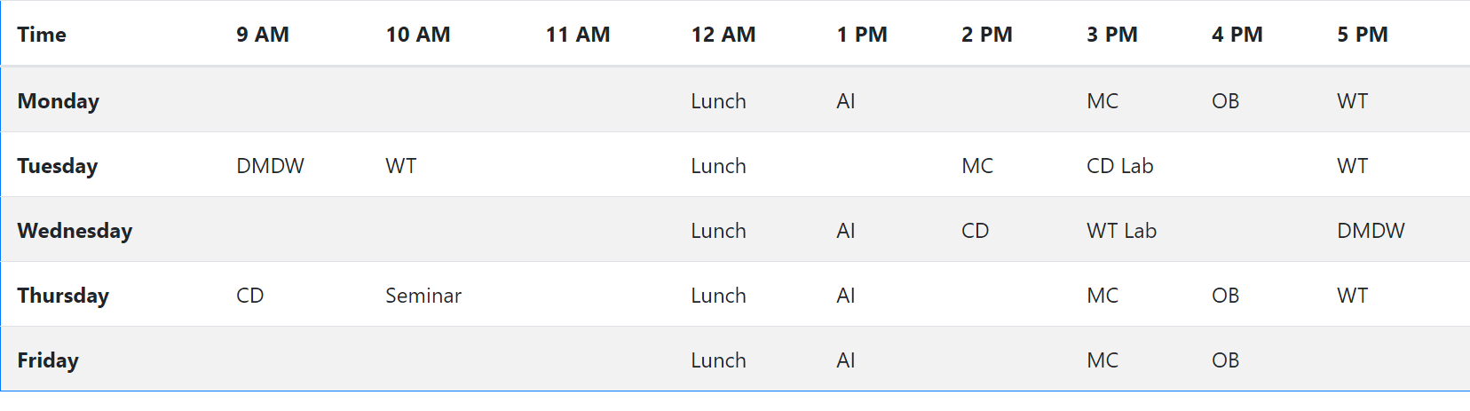
Question Two
<!DOCTYPE html>
<html>
<head>
<meta charset="utf-8">
<title>timetable</title>

<!-- css-stylesheets -->
<link rel="stylesheet" href="https://stackpath.bootstrapcdn.com/bootstrap/4.5.1/css/bootstrap.min.css" integrity="sha384-VCmXjywReHh4PwowAiWNagnWcLhlEJLA5buUprzK8rxFgeH0kww/aWY76TfkUoSX" crossorigin="anonymous">

<!-- bootstrap -->
<script src="https://code.jquery.com/jquery-3.5.1.slim.min.js" integrity="sha384-DfXdz2htPH0lsSSs5nCTpuj/zy4C+OGpamoFVy38MVBnE+IbbVYUew+OrCXaRkfj" crossorigin="anonymous"></script>
<script src="https://cdn.jsdelivr.net/npm/popper.js@1.16.1/dist/umd/popper.min.js" integrity="sha384-9/reFTGAW83EW2RDu2S0VKaIzap3H66lZH81PoYlFhbGU+6BZp6G7niu735Sk7lN" crossorigin="anonymous"></script>
<script src="https://stackpath.bootstrapcdn.com/bootstrap/4.5.1/js/bootstrap.min.js" integrity="sha384-XEerZL0cuoUbHE4nZReLT7nx9gQrQreJekYhJD9WNWhH8nEW+0c5qq7aIo2Wl30J" crossorigin="anonymous"></script>
</head>
<body>

<h1 class="display-1 container-lg">Our Solar System</h1>
<img src="planets.jpg" usemap="#image-map">

<map name="image-map">
<area target="_blank" alt="Sun" title="Sun" href="https://solarsystem.nasa.gov/solar-system/sun/overview/" coords="387,383,231,0,519,783,540,890,548,1080,532,1265,499,1546,478,1715,391,1921,276,2148,21,2160,16,25,198,12,280,66,342,157,412,301,433,437,400,449,515,713,433,379,474,497" shape="poly">
<area target="_blank" alt="Mercury" title="Mercury" href="https://solarsystem.nasa.gov/planets/mercury/overview/" coords="725,1083,38" shape="circle">
<area target="" alt="Venus" title="Venus" href="https://solarsystem.nasa.gov/planets/venus/overview/" coords="956,1080,87" shape="circle">
<area target="" alt="Earth" title="Earth" href="https://solarsystem.nasa.gov/planets/earth/overview/" coords="1269,1088,106" shape="circle">
<area target="" alt="Mars" title="Mars" href="https://solarsystem.nasa.gov/planets/mars/overview/" coords="1595,1087,108" shape="circle">
<area target="" alt="Jupiter " title="Jupiter " href="https://solarsystem.nasa.gov/planets/jupiter/overview/" coords="2130,1079,332" shape="circle">
<area target="" alt="Saturn" title="Saturn" href="https://solarsystem.nasa.gov/planets/saturn/overview/" coords="2814,1088,261" shape="circle">
<area target="" alt="Neptune" title="Neptune" href="https://solarsystem.nasa.gov/planets/neptune/overview/" coords="3284,1088,153" shape="circle">
<area target="" alt="Neptune" title="Uranus" href="https://solarsystem.nasa.gov/planets/uranus/overview/" coords="3646,1080,159" shape="circle">
</map>

</body>

